FINANCIAL TRANSACTIONS & LOANS DASHBOARD
Microsoft Power BI Project Report
Submitted By : Dharshini
Roll Number : E25FA053
Course : B.com Fintech & AI
Tool Used : Microsoft Power BI Desktop

1. Introduction
For this project, I developed an interactive Financial Transactions & Loans Dashboard using Microsoft Power BI. The purpose of the project was to analyse financial transactions, customer accounts, loan statuses, transaction types, and transaction values using a financial dataset.
The dashboard provides information about different types of financial transactions, including Deposits, Payments, Transfers, and Withdrawals. It also presents information about account distribution, active loans, active accounts, customer counts, and transaction activity across different months.
The main purpose of developing this dashboard was to convert raw financial data into a simple and interactive visual report. Instead of analysing large amounts of financial information manually, users can use KPI cards, charts, tables, and slicers to understand important financial indicators quickly.
The dashboard contains KPI cards, a column chart, a line chart, a doughnut chart, a horizontal bar chart, and a transaction summary table. Interactive slicers allow users to explore information by transaction type, account name, and year.
Overall, the project demonstrates how Power BI can be used to prepare financial data, calculate key performance indicators, create visualisations, and support financial data analysis.

2. Objectives
The main objectives of developing this dashboard were:
- To analyse financial transactions and customer account information.
- To calculate and display important financial KPIs.
- To identify the number of active loans and active accounts.
- To analyse the total transaction value.
- To compare account distribution across different account types.
- To analyse transaction activity across different months.
- To understand the distribution of loans by status.
- To compare transaction volumes across different transaction types.
- To analyse transaction values generated by different transaction categories.
- To present transaction counts and values in a summary table.
- To provide interactive filtering using slicers.
- To understand the use of Power Query for data preparation.
- To understand relationships between tables in Power BI.
- To apply DAX measures for financial calculations.
- To explore advanced Power BI features such as drill-down, report-page tooltips, and conditional formatting, where implemented.
- To present financial information in a clear and understandable visual format.

3. Dataset Description
The project uses a financial transactions and loans dataset containing information related to customers, accounts, loans, transaction types, transaction values, and transaction dates.
The dataset supports the analysis of customer accounts, loan statuses, monthly transaction trends, and the financial value of different transaction categories.
The major fields used in the dashboard include:
Field | Description
Account Type | Category used to classify customer accounts
TypeName | Type of financial transaction
StatusName | Status of a loan, such as Active, Closed, or Inactive
Transaction Date | Date on which a transaction occurred
Month | Month used for transaction trend analysis
Year | Year used for filtering transaction information
Account Name | Account-related field used for filtering
Transaction Count | Number of transactions
Transaction Value | Monetary value associated with transactions
Customer Information | Information used for customer-related analysis
Loan Information | Information used for loan-related analysis

The dataset provides information for analysing customer accounts, transaction activity, loan statuses, and financial transaction values from different perspectives.
The exact number and names of the source tables should be documented according to the dataset loaded into Power BI.
4. Data Preparation Using Power Query
Before creating the dashboard, I imported the financial dataset into Microsoft Power BI Desktop and examined the available columns and data types.
Power Query Editor was used to review and prepare the fields required for analysis. Numerical fields were checked for transaction counts and transaction values, while category fields were used to classify accounts, transaction types, and loan statuses.
The data preparation activities included:
- Importing the financial dataset into Power BI Desktop.
- Reviewing available columns and data types.
- Identifying numerical fields required for financial calculations.
- Checking account type and loan status categories.
- Reviewing transaction types such as Deposit, Payment, Transfer, and Withdrawal.
- Checking date and month fields for transaction trend analysis.
- Preparing the fields required for KPI cards, charts, and tables.
- Reviewing the prepared data to ensure that it could be used in the dashboard.
Other transformations, such as removing duplicate records, handling missing values, correcting date formats, and applying Trim and Clean operations, should be included if they were actually performed in Power Query.
These preparation steps helped organise the data for analysis and visualisation.

5. Data Modelling and Relationships
Data modelling is an important part of developing a Power BI report because it connects information stored in different tables.
Power BI Model view can be used to create and manage relationships between related tables. These relationships allow customer, account, loan, and transaction information to be analysed together.
For this project, the data model supports the account distribution chart, loan status chart, transaction trend chart, and transaction summary table.
The relationships should be checked to ensure that the correct columns are used as keys and that the cardinality and filter direction support the required analysis.
Where inactive relationships exist, they can be used in specific DAX calculations with the USERELATIONSHIP() function when the analysis requires an alternative relationship path.
The final model documentation should include the actual table names, relationship count, cardinality, filter direction, and inactive relationships identified in Model view.

6. DAX Measures
DAX stands for Data Analysis Expressions. It is used in Power BI to create calculations and measures for analysing data and displaying key financial indicators.
The dashboard displays four main KPI cards and also uses transaction counts and transaction values in its charts and summary table.
6.1 Active Loans
This measure represents the number of loans classified as active.
Purpose: It provides an overview of the active loan portfolio.
Dashboard result: 230 active loans.

6.2 Active Accounts
This measure represents the number of active customer accounts.
Purpose: It helps understand the number of accounts currently classified as active.
Dashboard result: Approximately 1,297 active accounts.

6.3 Total Transaction Value
This measure calculates the total monetary value of the transactions included in the current report context.
Purpose: It provides an overview of the total financial value represented by the transaction data.
Dashboard result: Approximately $122.69 million.

6.4 Total Customers
This measure represents the number of customers included in the dashboard calculation.
Purpose: It provides an overview of the customer base represented in the report.
Dashboard result: Approximately 1,072 customers.

6.5 Total Transactions
This calculation represents the number of transactions included in the transaction summary.
Purpose: It helps analyse transaction activity and compare transaction volumes across different categories.
Dashboard result: 48,510 transactions.
The exact DAX formulas should be copied from the measures created in the Power BI file. The source fields, aggregation methods, and filter conditions must be checked before including formulas in the final report.
7. Dashboard Visualisations
The dashboard contains several visualisations, each designed to present a different aspect of the financial dataset.
7.1 KPI Cards
Four KPI cards are displayed near the top of the dashboard.
KPI | Dashboard Value
Active Loans | 230
Active Accounts | 1.297K
Total Transaction Value | $122.69305081M
Total Customers | 1.072K
These KPI cards provide a quick overview of the main financial indicators without requiring users to examine individual charts.
7.2 Accounts by Accounts Type
A column chart titled “Accounts by Accounts Type” displays the total number of accounts across five categories:
- Business
- Youth
- Savings
- Payroll
- Checking
The chart shows that Business accounts have the highest count among the displayed categories. Youth and Savings accounts follow, while Payroll and Checking have comparatively lower counts.
Purpose:
- To compare the number of accounts across categories.
- To identify the account category with the highest representation.
- To understand the distribution of accounts across the available account types.
This visual helps present account distribution in an easy-to-understand format.
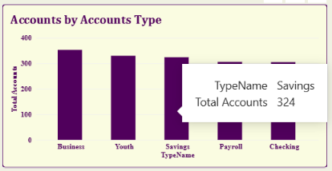

7.3 Transactions Over Time
A line chart titled “Transactions Over Time” displays monthly transaction activity from January to December.
The chart shows relatively high transaction activity in January, followed by a sharp decline in February. Transaction activity then fluctuates throughout the remaining months, with a comparatively stable pattern and a slight increase towards December.
Purpose:
- To analyse monthly transaction activity.
- To identify months with relatively high or low transaction counts.
- To observe changes in transaction activity over time.
- To compare monthly transaction patterns.
The Year slicer can be used to examine transaction activity for different selected periods.
If the dataset contains transactions from multiple years, the month aggregation should be checked to ensure that the chart represents the intended period.
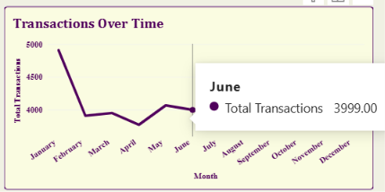
7.4 Total Loans by StatusName
A doughnut chart titled “Total Loans by StatusName” displays loan distribution across three statuses:
- Active
- Closed
- Inactive
The chart currently displays approximately 33.33% for each status.
Purpose:
- To compare loan distribution across statuses.
- To understand the proportion of loans classified as active, closed, or inactive.
- To provide a visual summary of the loan portfolio.
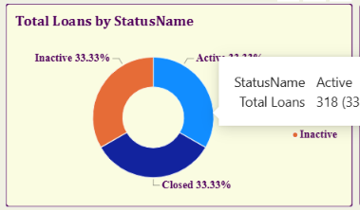
The equal percentages should be verified against the underlying loan counts before being treated as a confirmed finding.

7.5 Transactions by Type
A horizontal bar chart titled “Transactions by Type” compares the number of transactions across four categories.
Transaction Type | Number of Transactions
Deposit | 14,760
Transfer | 14,478
Withdrawal | 14,412
Payment | 4,860
Total | 48,510
Deposit transactions have the highest count, followed by Transfers and Withdrawals. Payment transactions have the lowest count.
Purpose:
- To compare transaction volumes across categories.
- To identify the most frequently occurring transaction type.
- To understand the relative contribution of each category to the overall transaction count.
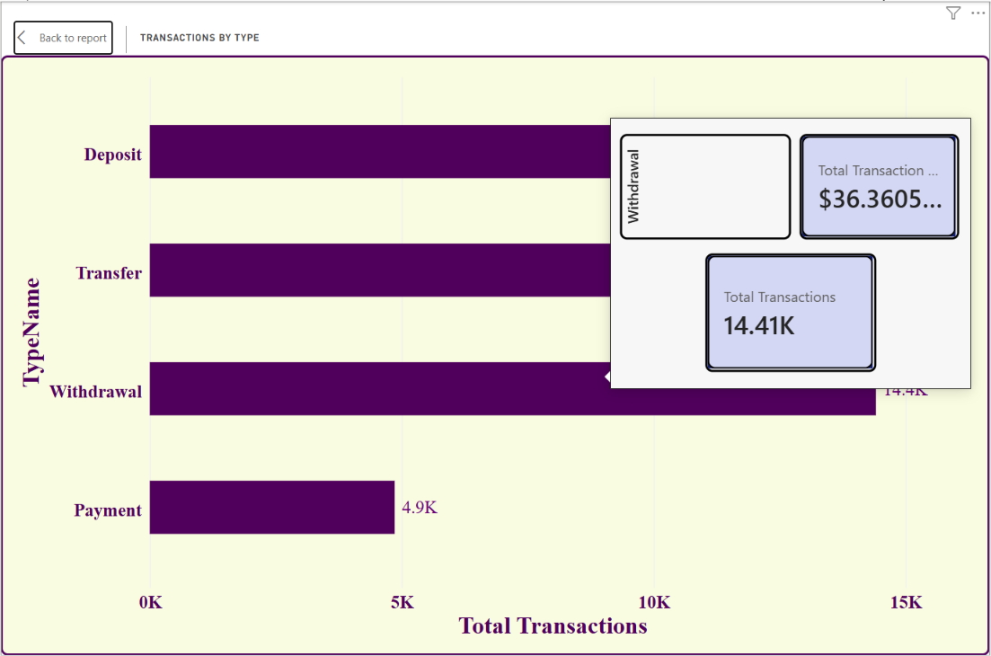
The horizontal bar chart makes it easier to compare transaction volumes visually.
7.6 Transaction Summary
The Transaction Summary table provides a detailed comparison of transaction counts and transaction values.
It contains three main columns:
- TypeName
- Total Transactions
- Total Transaction Value
The displayed values are:
Transaction Type | Total Transactions | Total Transaction Value
Deposit | 14,760 | $37,255,964.91
Payment | 4,860 | $12,293,101.75
Transfer | 14,478 | $36,783,420.00
Withdrawal | 14,412 | $36,360,564.15
Total | 48,510 | $122,693,050.81
The summary table presents transaction counts and financial values in one place. It helps compare the financial contribution of each transaction category.
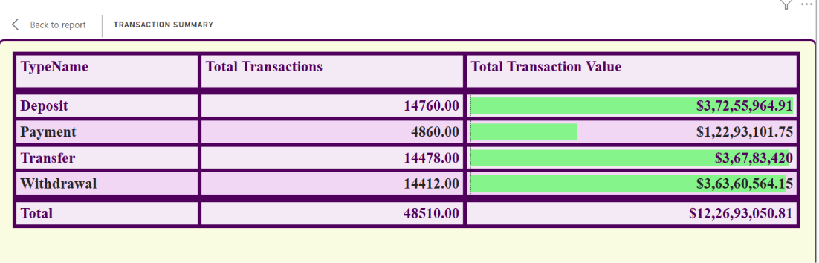
The table also uses green data bars to provide a visual representation of transaction values. Longer bars indicate relatively higher values, making comparisons easier.
8. Slicers and Interactivity
The dashboard includes three slicers that allow users to filter the displayed information.
8.1 Transaction Types
The Transaction Types slicer allows users to select a transaction category or view all categories.
This helps users examine the relevant transaction activity and compare different transaction types.
8.2 Account Name
The Account Name slicer allows users to filter the report using the available account names.
This provides an additional way to explore financial information according to the selected account.
8.3 Year
The Year slicer displays a range from 2020 to 2026.
Users can select a year or a range of years to examine transaction activity for the selected period.
8.4 Visual Interactions
Power BI allows visuals to interact with one another. Depending on the interaction settings, selecting a category or applying a slicer can filter or highlight related information in other visuals.
The Edit interactions feature can be used to configure whether one visual filters, highlights, or does not affect another visual.
These features make the dashboard more useful than a static report because users can explore the financial data according to their requirements.
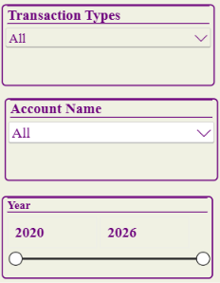
9. Drill-Down Analysis
Drill-down is a Power BI feature that allows users to move from summarised information to more detailed levels of analysis.
For transaction trend analysis, a date hierarchy can be used to explore data at different levels, such as year, quarter, month, and day, depending on the hierarchy configured in the report.
The Transactions Over Time visual can be configured with a date hierarchy to allow users to navigate from a higher-level summary to more detailed time periods.
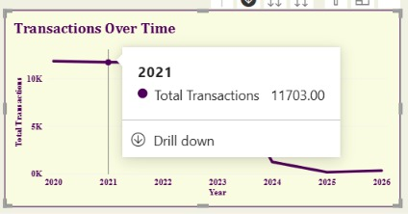
Year level: Users can examine overall transaction activity across different years.

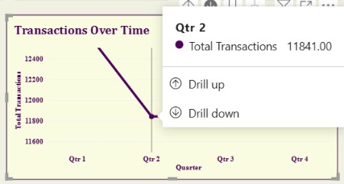
Quarter level: Users can compare transaction activity across quarters within a selected year.

Month level: Users can examine transaction patterns across individual months.
The drill-down feature helps identify changes in transaction activity over time and allows users to investigate a selected period in greater detail.
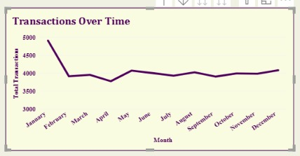
Screenshots of the actual year, quarter, and month views should be included as evidence of the implemented drill-down functionality.

10. Report-Page Tooltip
Report-page tooltips in Power BI provide additional information when users hover over a data point in a visual.
A separate tooltip page can be created by enabling the tooltip setting in Page information and configuring the page size as Tooltip. Cards and other suitable visuals can then be added to display contextual information.
The tooltip page can be assigned to a chart through its Tooltip settings. When a user hovers over a data point, the tooltip can display relevant information without requiring the user to leave the main dashboard.
For this project, a tooltip page can display information such as:
- Transaction Type
- Total Transactions
- Total Transaction Value
This feature provides a more detailed view of transaction activity while keeping the main dashboard simple and uncluttered.
Screenshots of the configured tooltip page and its appearance when hovering over a chart should be included as evidence of the implemented feature.
11. Conditional Formatting
Conditional formatting improves the readability of financial information by using visual indicators to represent numerical values.
In the Transaction Summary table, green data bars are displayed in the Total Transaction Value column. The length of each bar provides a visual comparison of the monetary values across Deposit, Payment, Transfer, and Withdrawal categories.
This makes it easier to identify categories with relatively high or low transaction values without relying only on the numerical figures.
The conditional formatting improves readability and makes differences between transaction categories easier to identify.

12. Key Findings
Based on the values displayed in the dashboard, the following observations can be made:
- Customer base: The dashboard displays approximately 1,072 customers.
- Active accounts: There are approximately 1,297 active accounts in the displayed results.
- Active loans: The dashboard reports 230 active loans.
- Transaction volume: The transaction summary reports 48,510 transactions across the four displayed transaction categories.
- Transaction value: The total transaction value is approximately $122.69 million.
- Account distribution: Business accounts have the highest count among the five account categories displayed in the column chart.
- Monthly transaction activity: January shows the highest visible transaction activity, followed by a noticeable decline in February. The remaining months show fluctuations in transaction volume.
- Loan status: The doughnut chart displays Active, Closed, and Inactive statuses at approximately 33.33% each. These proportions should be verified against the underlying loan counts.
- Transaction type comparison: Deposits have the highest transaction count at 14,760, while Payments have the lowest count at 4,860.
- Transaction values: Deposits contribute the largest transaction value among the four displayed categories, followed by Transfers, Withdrawals, and Payments.
- Interactive analysis: The transaction type, account name, and year slicers provide ways to explore the dashboard using different selections.
These findings demonstrate how the dashboard can be used to analyse financial activity from different perspectives.
13. Conclusion
This project helped me understand how Microsoft Power BI can be used to transform financial data into an interactive visual report.
By developing the Financial Transactions & Loans Dashboard, I explored how KPI cards, charts, tables, and slicers can be used to analyse customers, accounts, loans, and transactions.
The KPI cards provide a quick overview of active loans, active accounts, total customers, and total transaction value. The charts help compare account types, analyse monthly transaction activity, examine loan statuses, and compare transaction volumes. The transaction summary table provides a detailed view of transaction counts and monetary values.
The project also provided an opportunity to understand data preparation, data modelling, DAX calculations, and data visualisation. Advanced Power BI features such as drill-down, report-page tooltips, and conditional formatting can further improve the dashboard's usability and analytical capabilities.
Overall, this project improved my understanding of financial data analysis and dashboard development using Microsoft Power BI. It demonstrated how raw financial data can be transformed into meaningful visual insights that make information easier to understand and analyse.

